LC#56 MERGE INTERVALS
APPROACH 1: using arraylist
TC:O(N LOG N) , SC : O(N)
->custom sort based on the starting time
->check if the res list is empty or if the last value’s [1] is less than the new interval[0]
-> if so push to the array list else alter the end interval[1] of the res list last value
class Solution {
public int[][] merge(int[][] intervals) {
Arrays.sort(intervals , (a,b) -> a[0] - b[0]);
List<int[]> res = new ArrayList();
for(int[] ele : intervals)
{
if(res.isEmpty() || res.get(res.size()-1)[1]<ele[0])
res.add(ele);
else
res.get(res.size()-1)[1] = Math.max(res.get(res.size()-1)[1], ele[1]);
}
return res.toArray(new int[res.size()][]);

}
}

USING STACK:
import java.util.*;

class Solution {
public int[][] merge(int[][] intervals) {
Arrays.sort(intervals, (a, b) -> a[0] - b[0]);
Stack<int[]> stack = new Stack<>();

for (int[] curr : intervals) {
if (stack.isEmpty() || stack.peek()[1] < curr[0]) {
stack.push(curr);
} else {
stack.peek()[1] = Math.max(stack.peek()[1], curr[1]);
}
}

return stack.toArray(new int[stack.size()][]);
}
}

USING TREE MAP:
import java.util.*;

class Solution {
public int[][] merge(int[][] intervals) {
TreeMap<Integer, Integer> map = new TreeMap<>();
for (int[] it : intervals) {
map.put(it[0], map.getOrDefault(it[0], 0) + 1);
map.put(it[1], map.getOrDefault(it[1], 0) - 1);
}

List<int[]> res = new ArrayList<>();
int active = 0, start = 0;
for (int key : map.keySet()) {
if (active == 0) start = key;
active += map.get(key);
if (active == 0) res.add(new int[]{start, key});
}

return res.toArray(new int[res.size()][]);
}
}

LC#57 INSERT NTERVALS TC:O(N) , SC :O(N)
Example 1:
Input: intervals = [[1,3],[6,9]], newInterval = [2,5]
Output: [[1,5],[6,9]]

Example 2:
Input: intervals = [[1,2],[3,5],[6,7],[8,10],[12,16]], newInterval = [4,8]
Output: [[1,2],[3,10],[12,16]]
Explanation: Because the new interval [4,8] overlaps with [3,5],[6,7],[8,10].

APPROACH:
->separate as three parts not affecting , merging , remaining
->compare the int[][1] < newInterval[0] such that no overlap
->overlapping case : int[][0] <= newInterval[1] , add the interval outside the loop
->remaining as it

CODE:
class Solution {
public int[][] insert(int[][] intervals, int[] newInterval) {
ArrayList<int[]> res = new ArrayList();
int i = 0 , n = intervals.length;
//putting previous intervals
while(i<n && intervals[i][1] < newInterval[0])
{
res.add(intervals[i]);
i++;
}
//overlapping intervals
while(i<n && intervals[i][0] <= newInterval[1])
{
newInterval[0] = Math.min(newInterval[0], intervals[i][0]);
newInterval[1] = Math.max(newInterval[1], intervals[i][1]);
i++;
}
res.add(newInterval);
//putting remaining intervals
while(i<n)
{
res.add(intervals[i]);
i++;
}
return res.toArray(new int[res.size()][]);
}
}
LC#986 INTERVAL LIST INTERSECTIONS
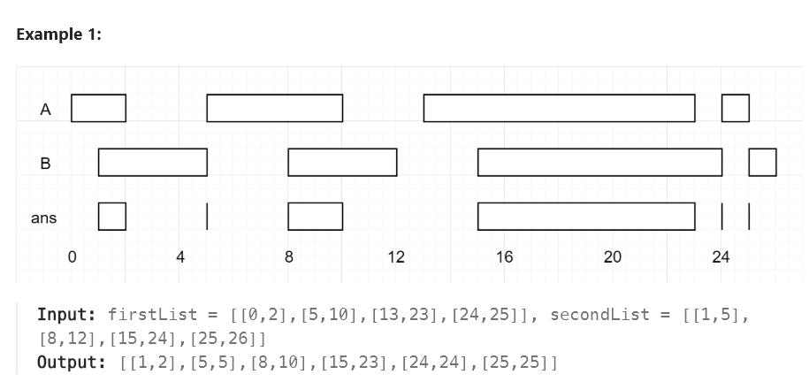
APPROACH:
->compare the intervals of first and second accordingly first max and second min
->check whether the first < second
-> check the condition of end1 and end2
end1< end2 =>i++
else j++

CODE:
class Solution {
public int[][] intervalIntersection(int[][] firstList, int[][] secondList) {
int l1 = firstList.length , l2 = secondList.length ;
if(l1 ==0 || l2==0)
return new int[0][];
ArrayList <int[]> res = new ArrayList();
int i = 0 , j = 0 ;
while(i<l1 && j<l2)
{
int st = Math.max(firstList[i][0], secondList[j][0]);
int end = Math.min(firstList[i][1] , secondList[j][1]);
if (st <= end)
res.add(new int[]{st, end});
if (firstList[i][1] < secondList[j][1])
i++;
else
j++;
}
return res.toArray(new int[res.size()][]);
}
}

LC#2406
class Solution {
public int minGroups(int[][] intervals) {
Arrays.sort(intervals, (a, b) -> a[0] != b[0] ? Integer.compare(a[0], b[0]) : Integer.compare(a[1], b[1]));
PriorityQueue<Integer> pq = new PriorityQueue<>();
for (int[] it : intervals) {
int s = it[0], e = it[1];
if (!pq.isEmpty() && pq.peek() < s)
pq.poll();
pq.offer(e);
}
return pq.size();

}
}

